10.9

Range bound day 9730 to 9600.

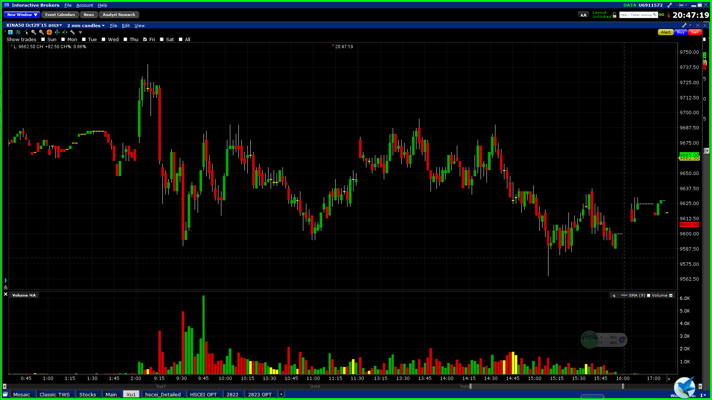

10.12

Rallies 350 points in the morning. PTC in the afternoon.

Morning short sold in an apparent trend (something to be avoided)

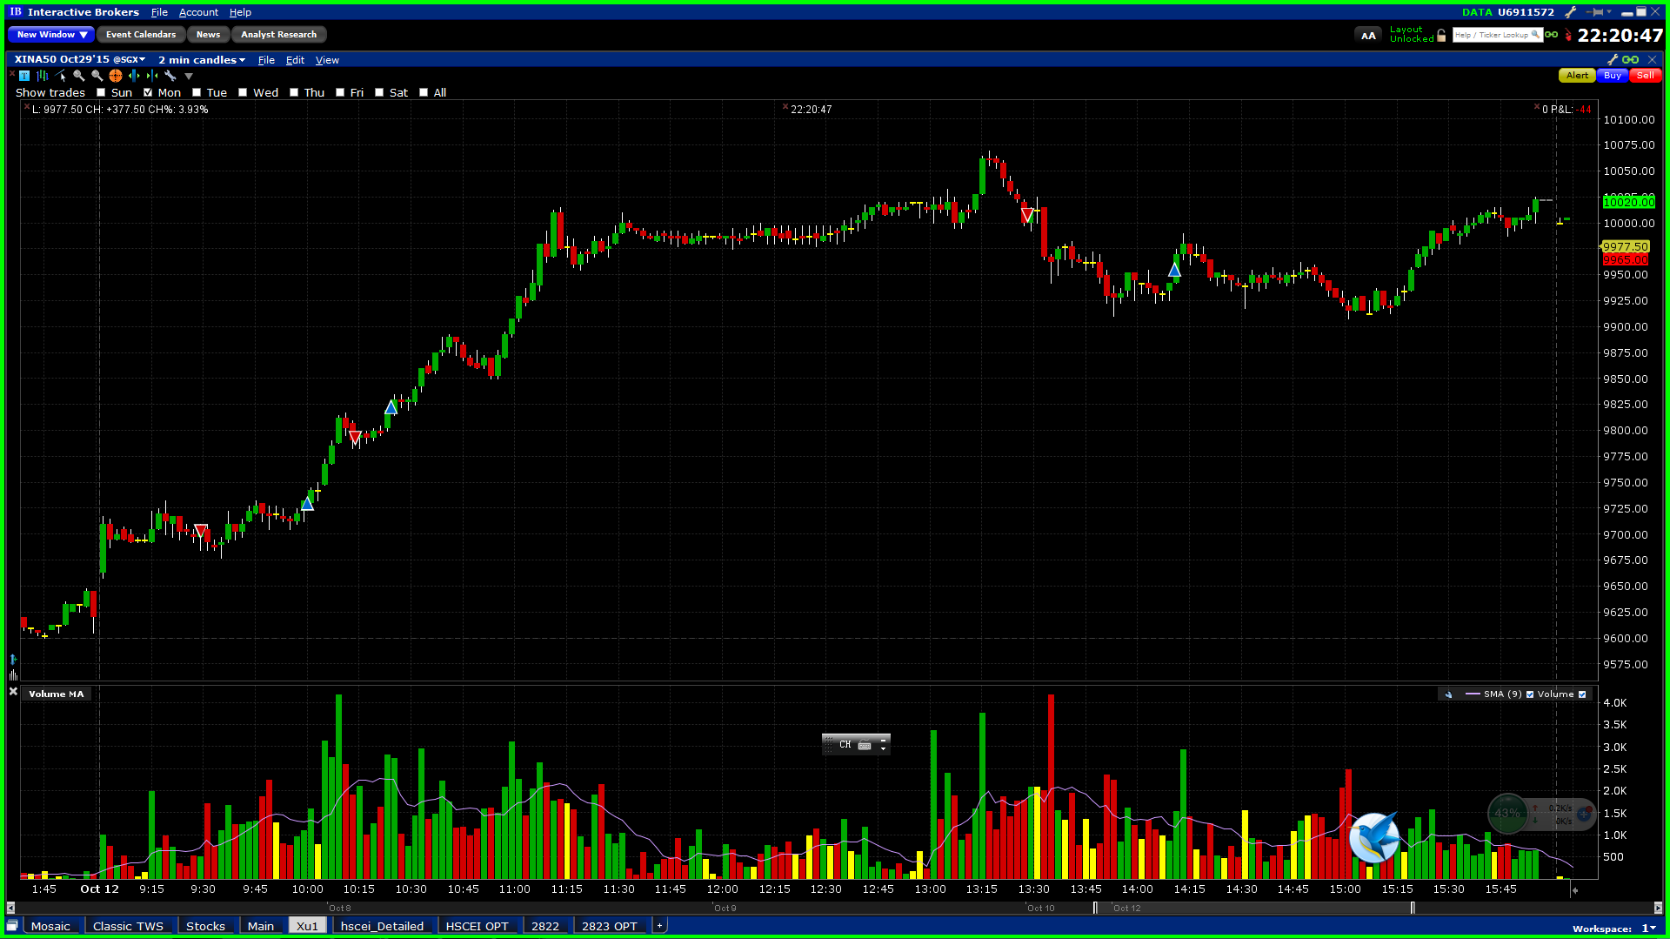

10/13

Falls to yesterday’s open level

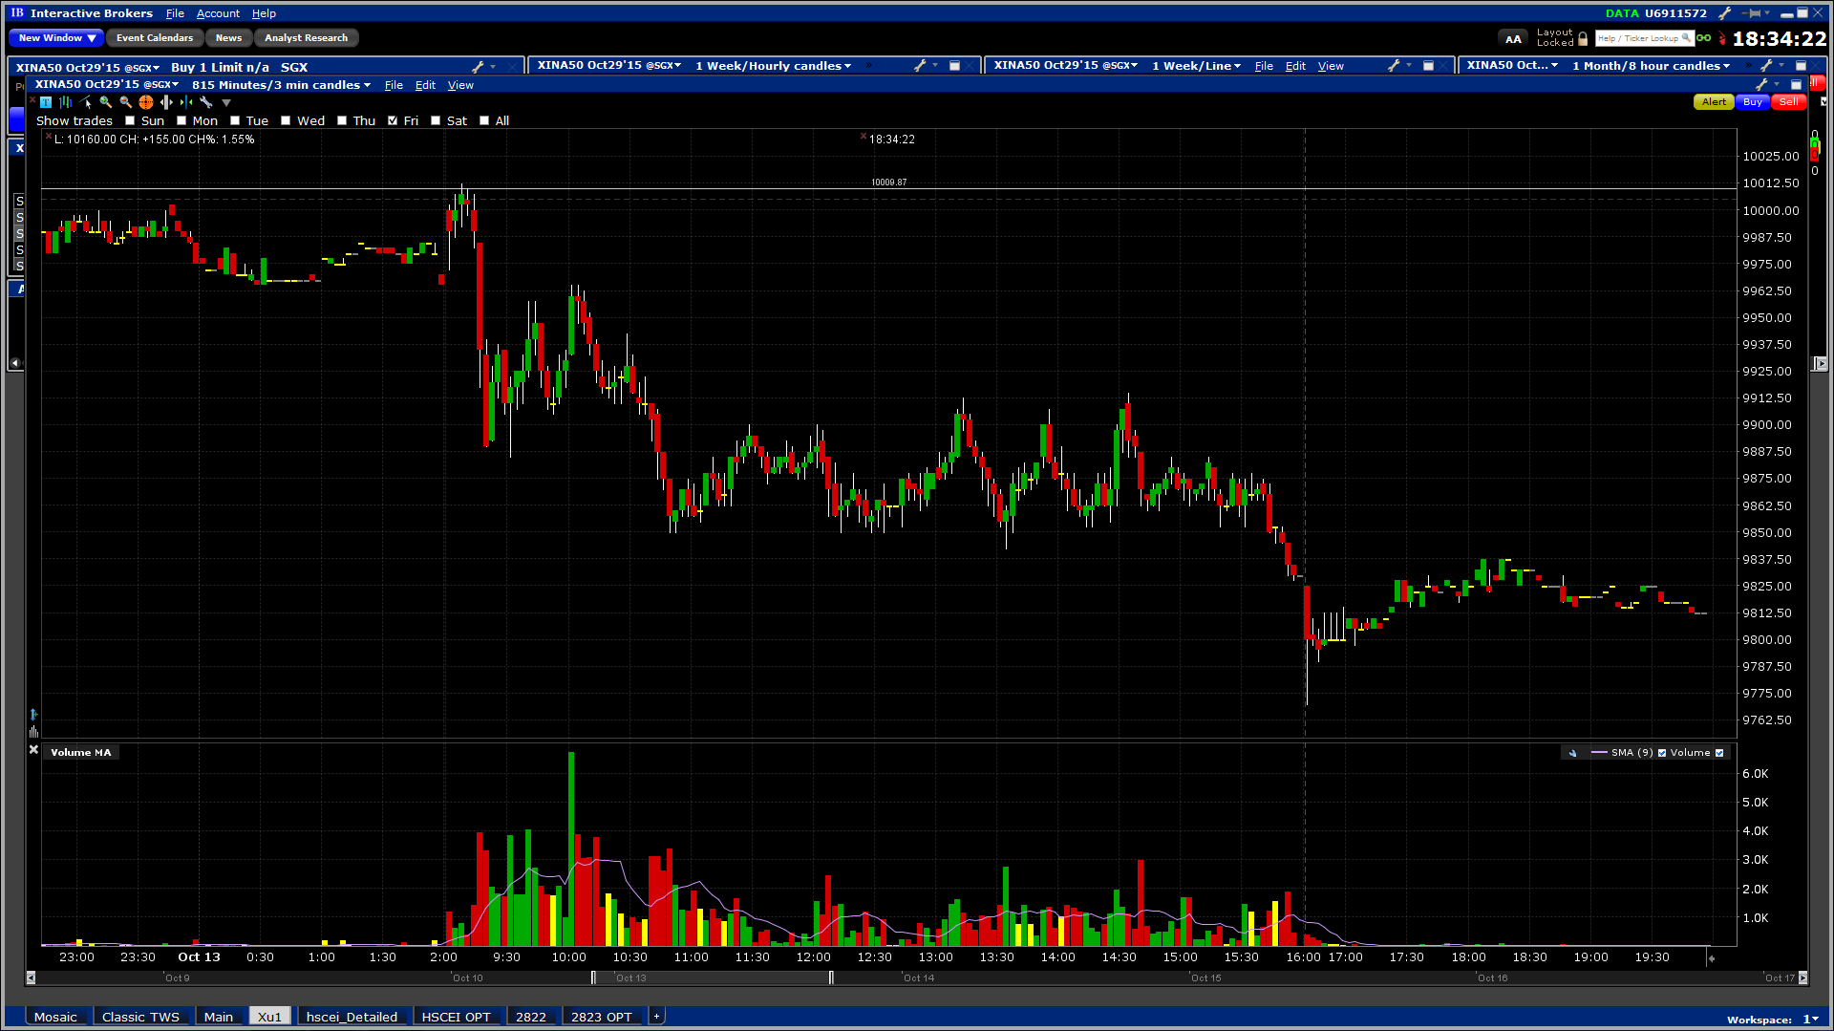

10/14 Wednesday

It tries to rally but failed.

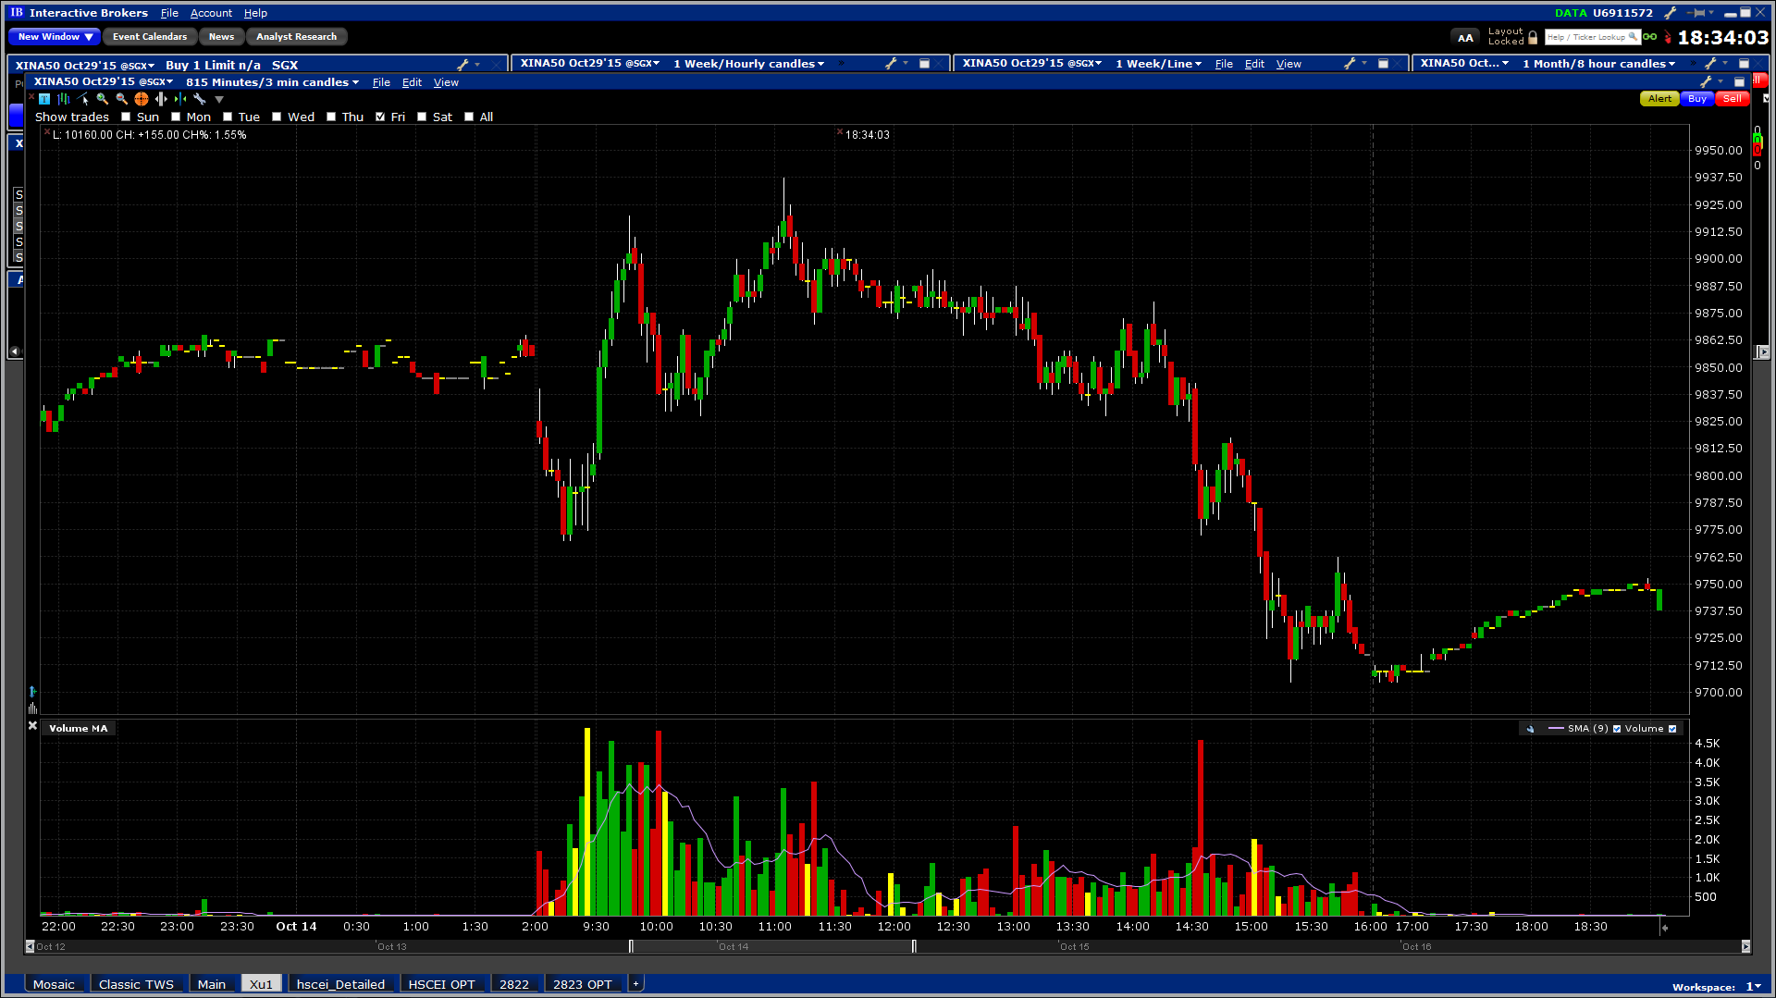

10.15 Thursday

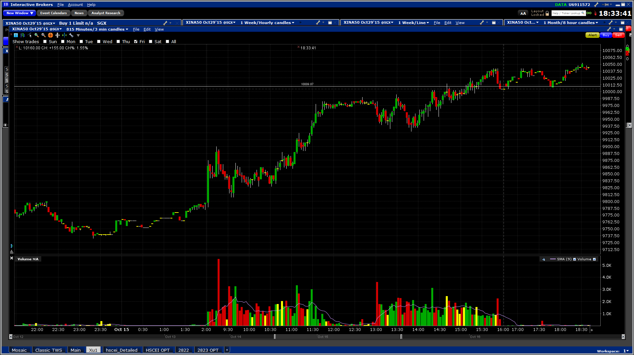

10.16.2015 Friday

PTC

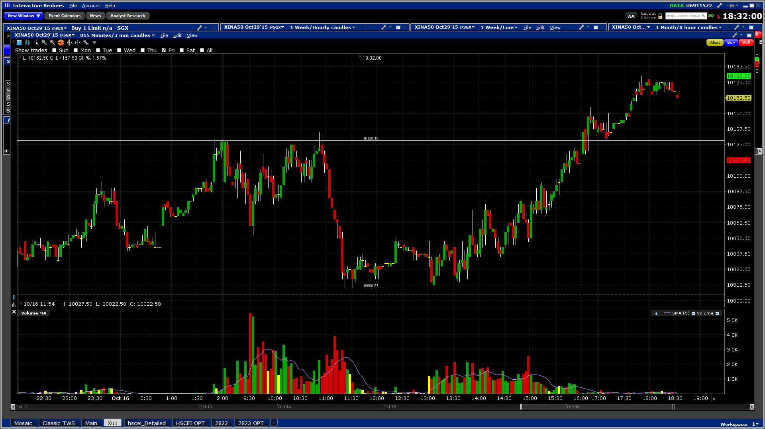

10.19.2015

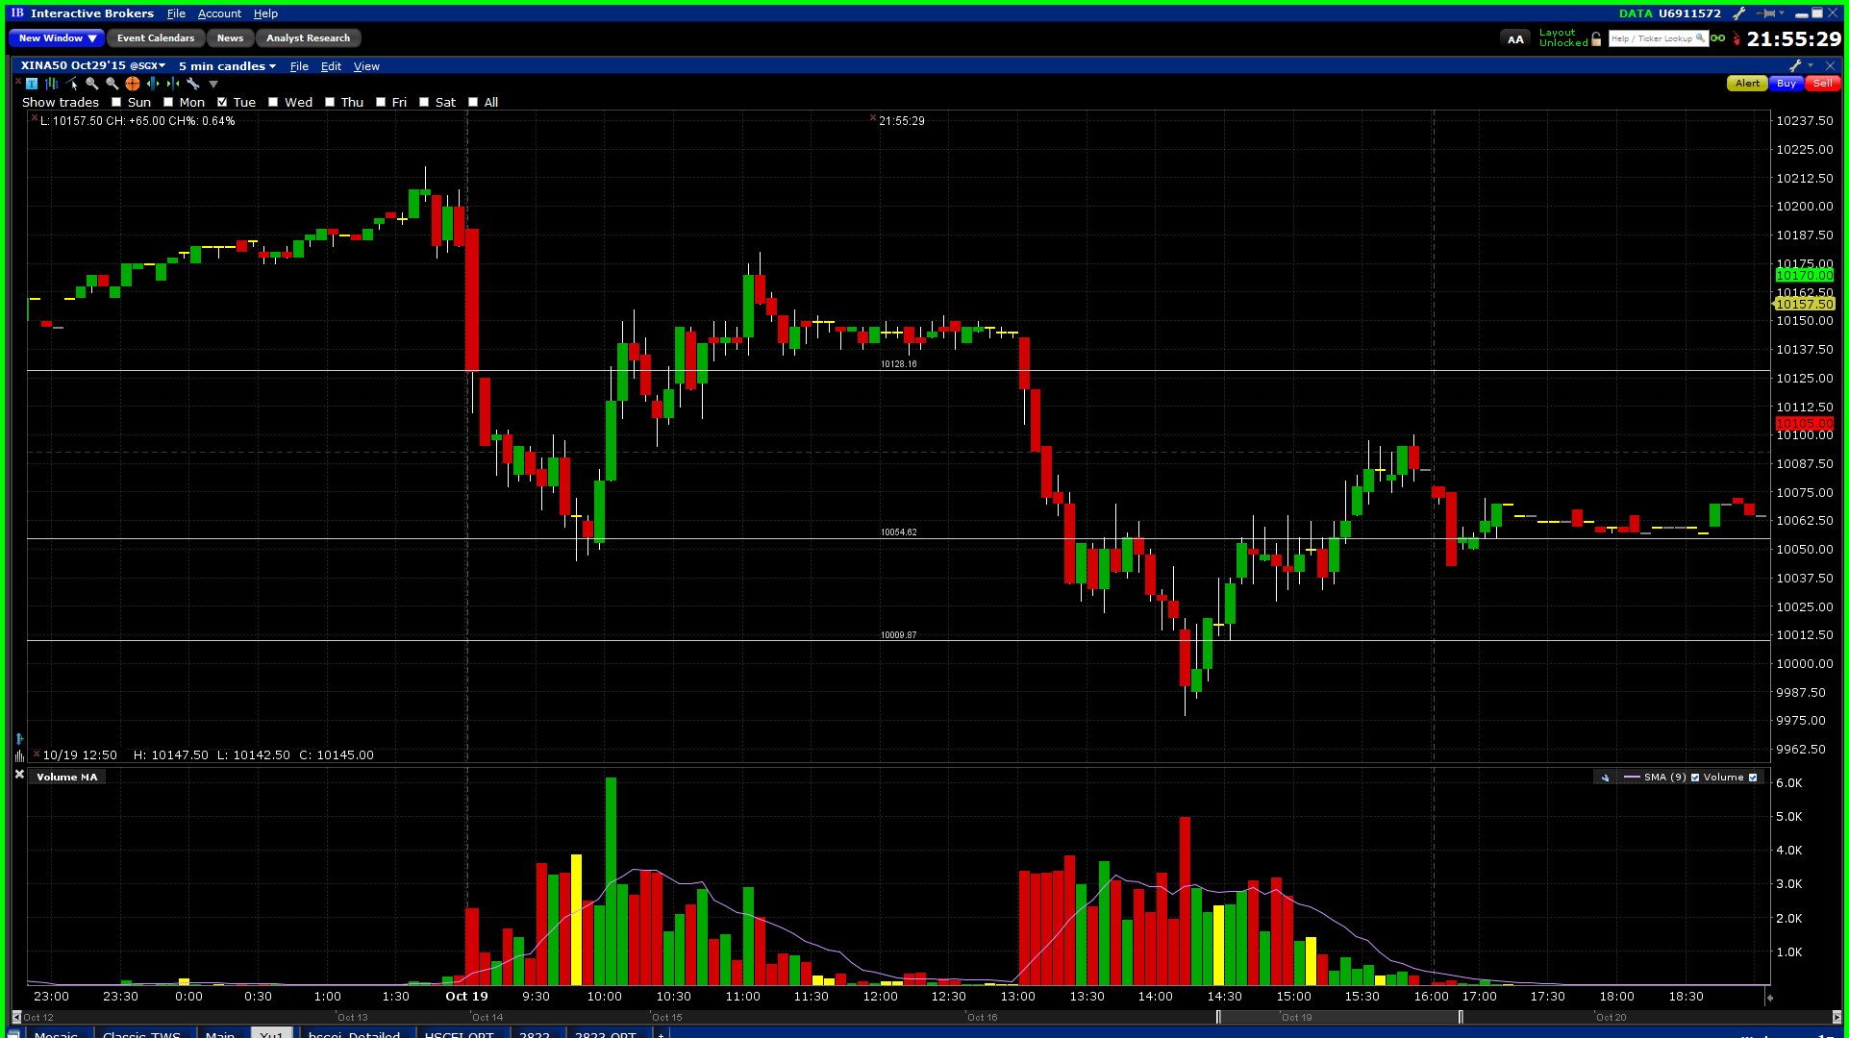

10.20.2015

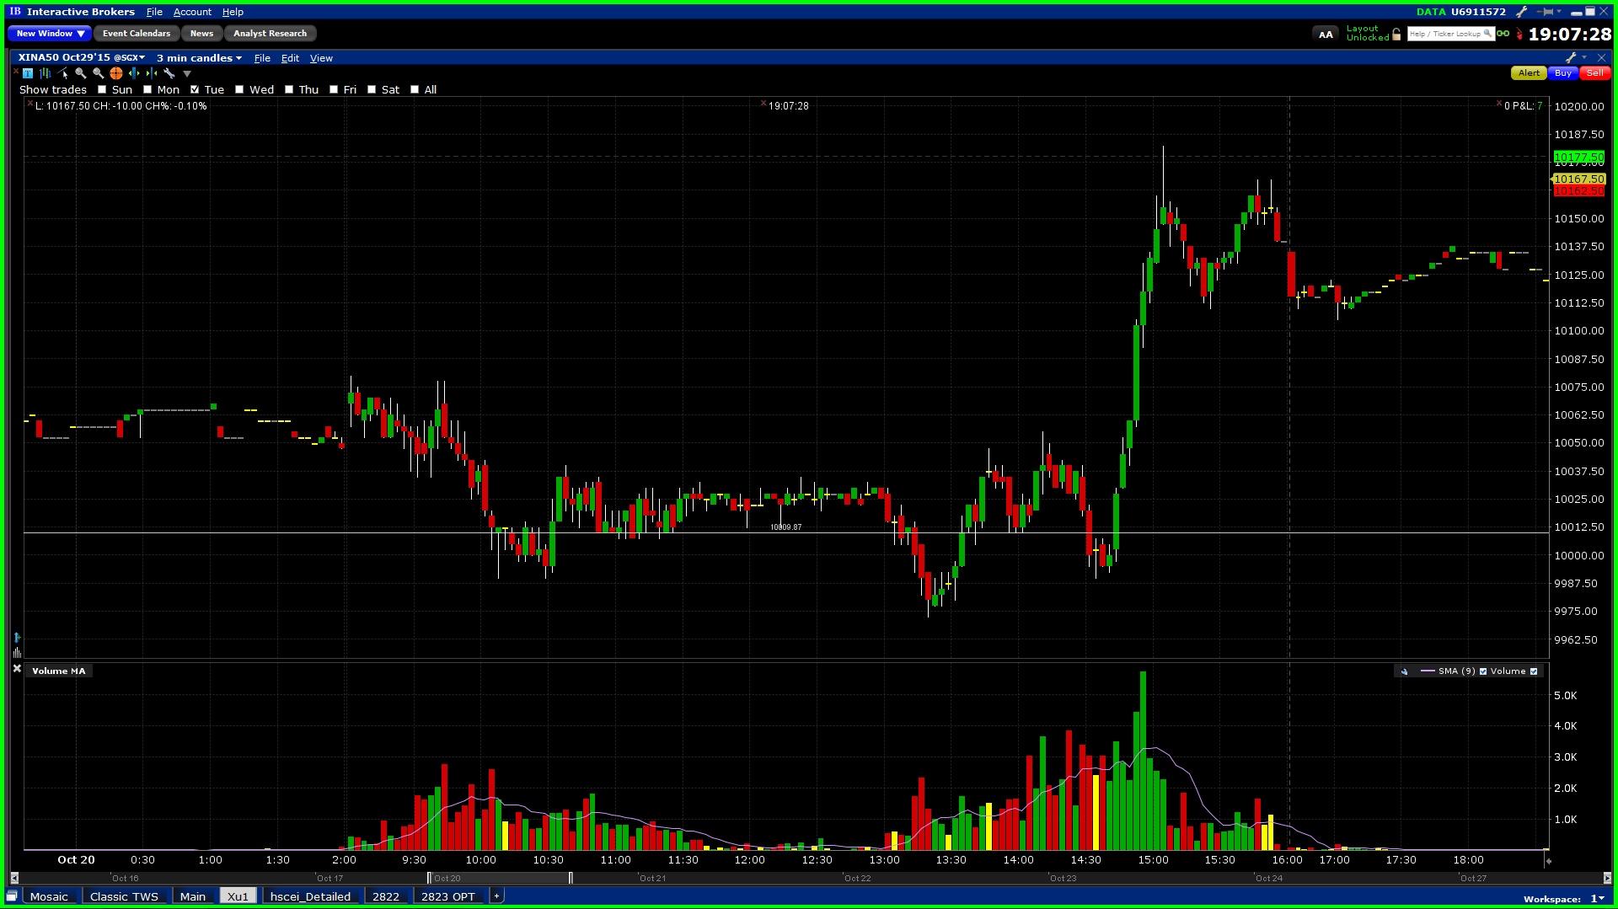

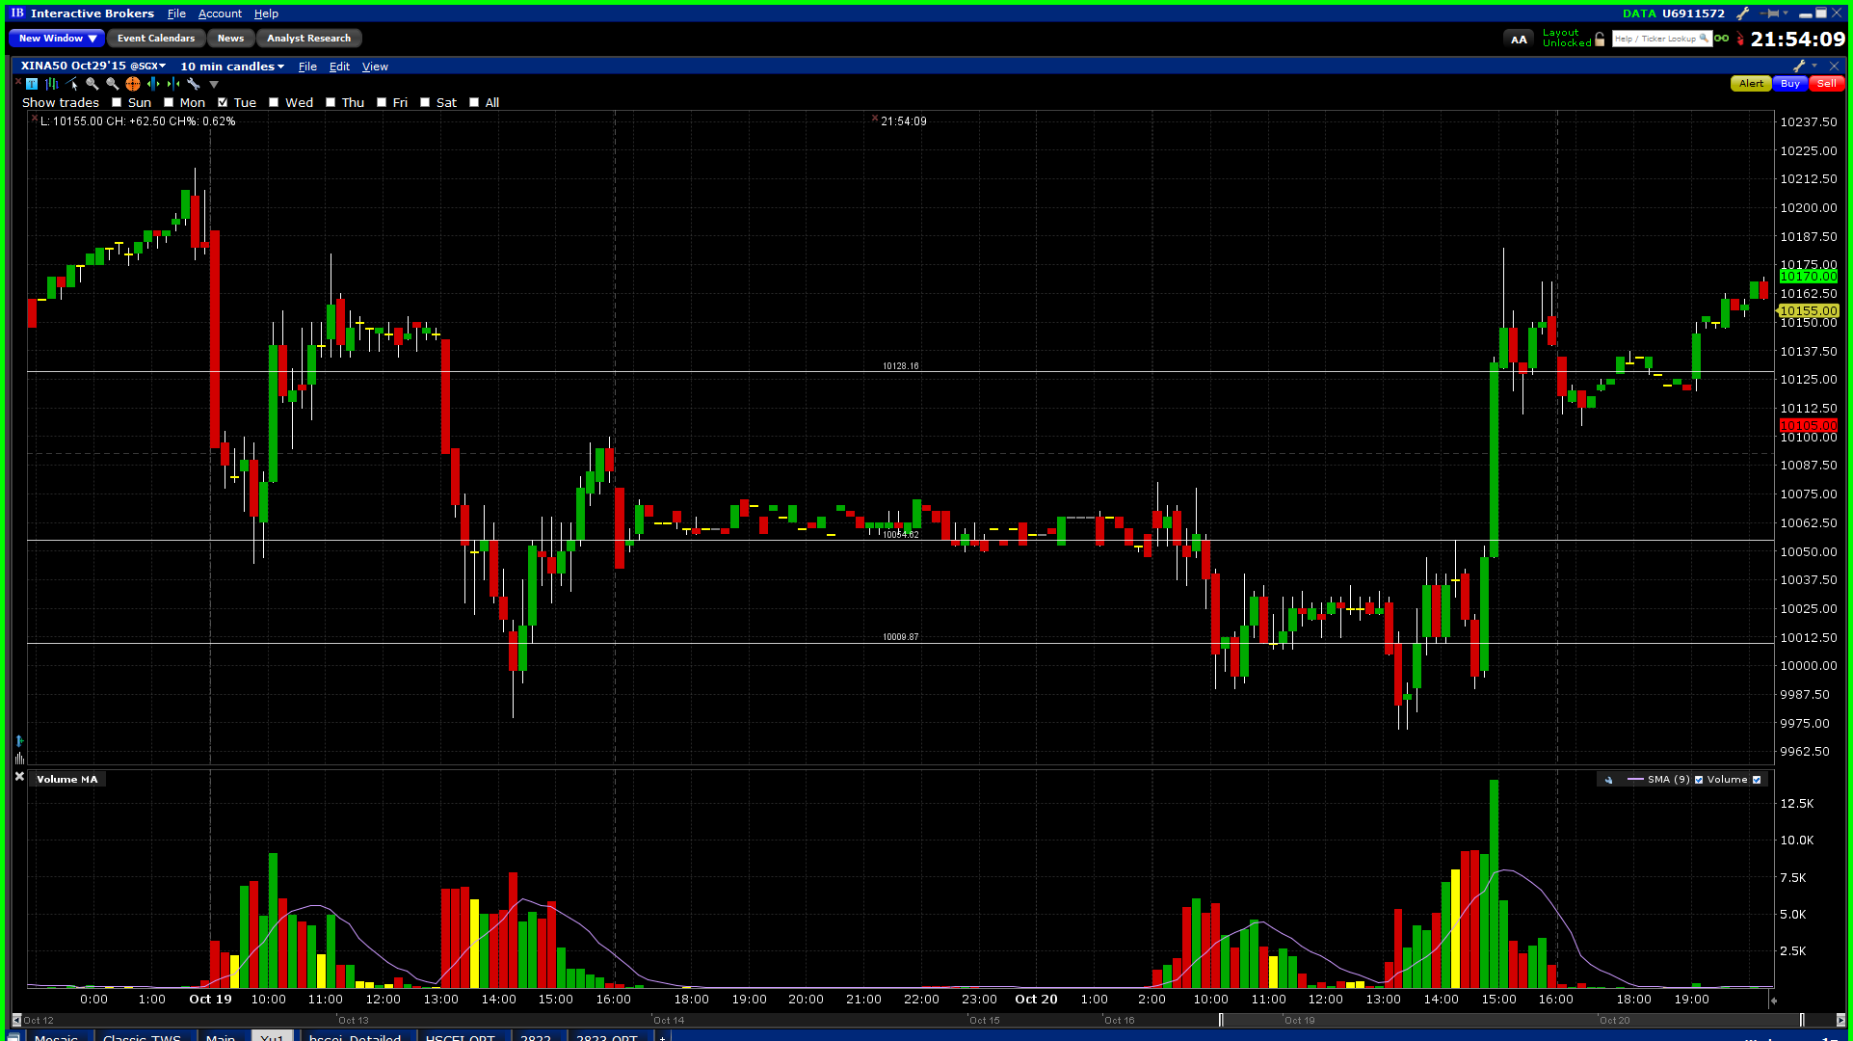

10.21

Retraces back to Oct14 highs.

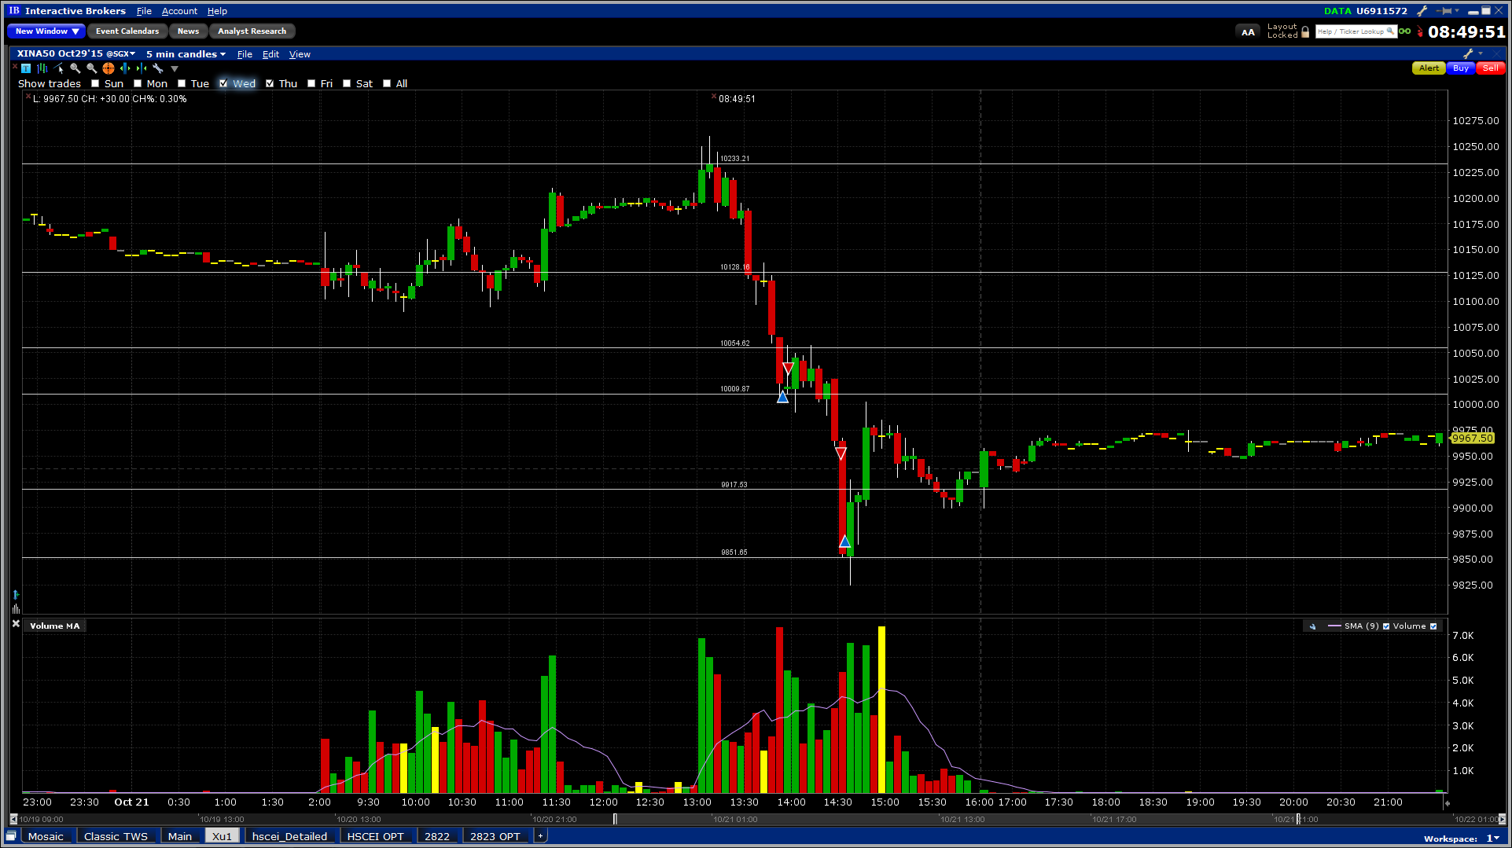

Oct1 – Oct 21

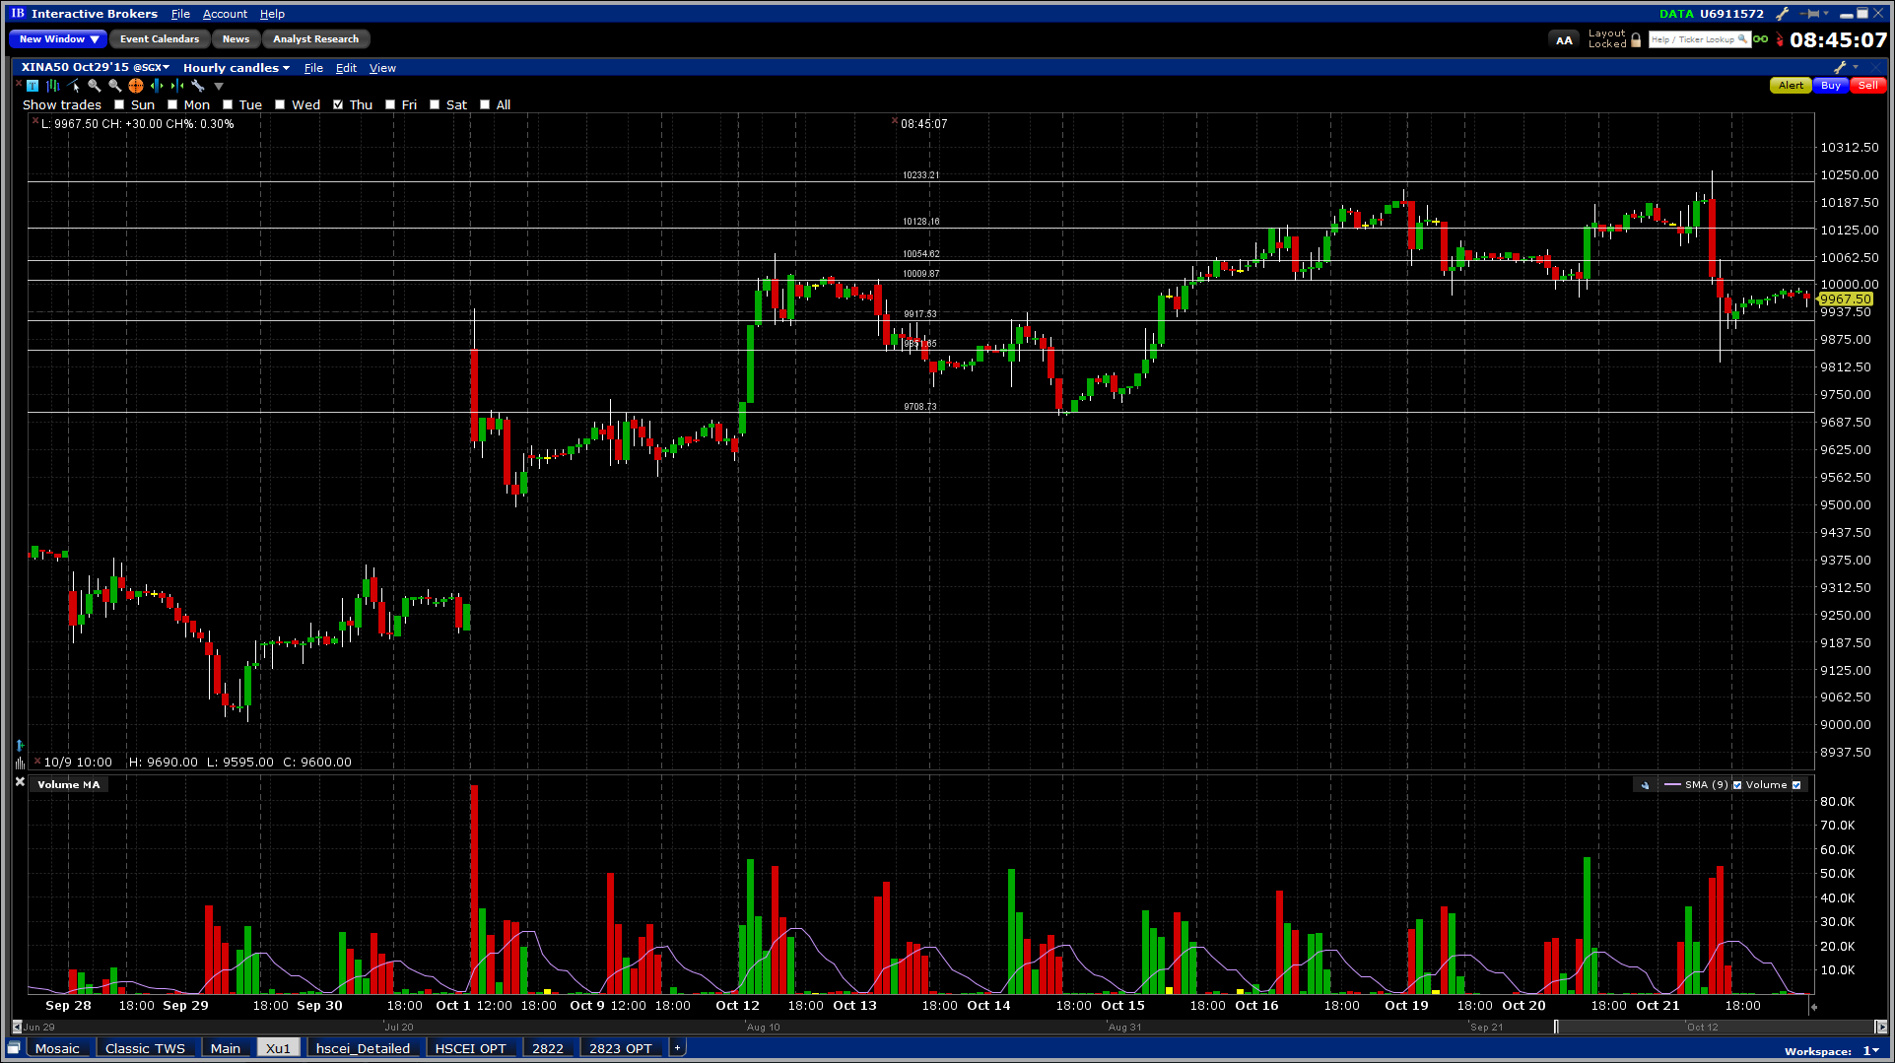

10.22

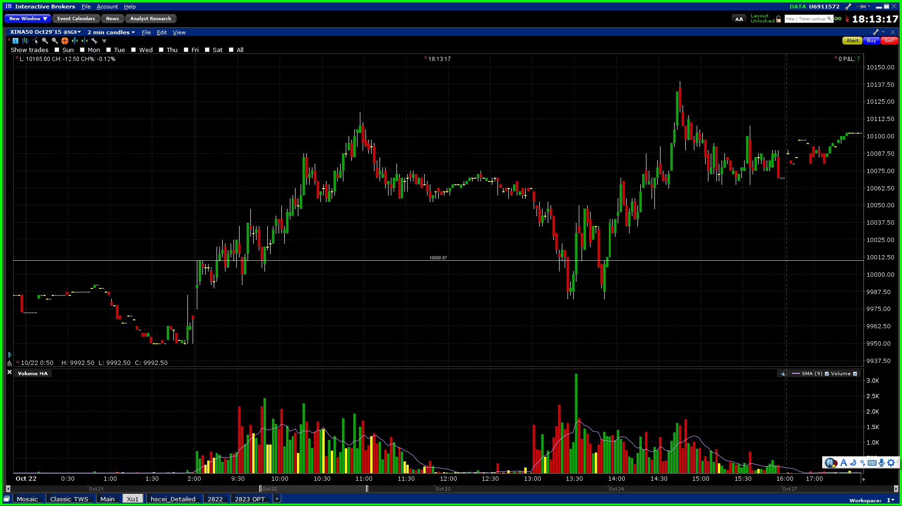

10.23 (Fri)

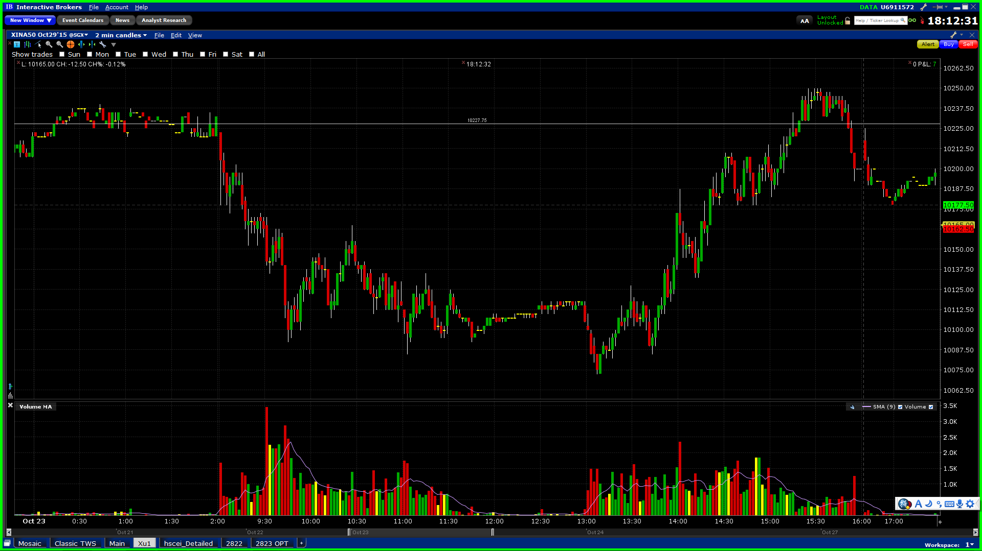

**10.26.2015**

Rate cut @ 7.17pm oct 23. Open low, morning quiet, afternoon down. The rate cut was perceived to have no impact on the markets whatsoever. The market completely reverted to the ex-rate cut level.

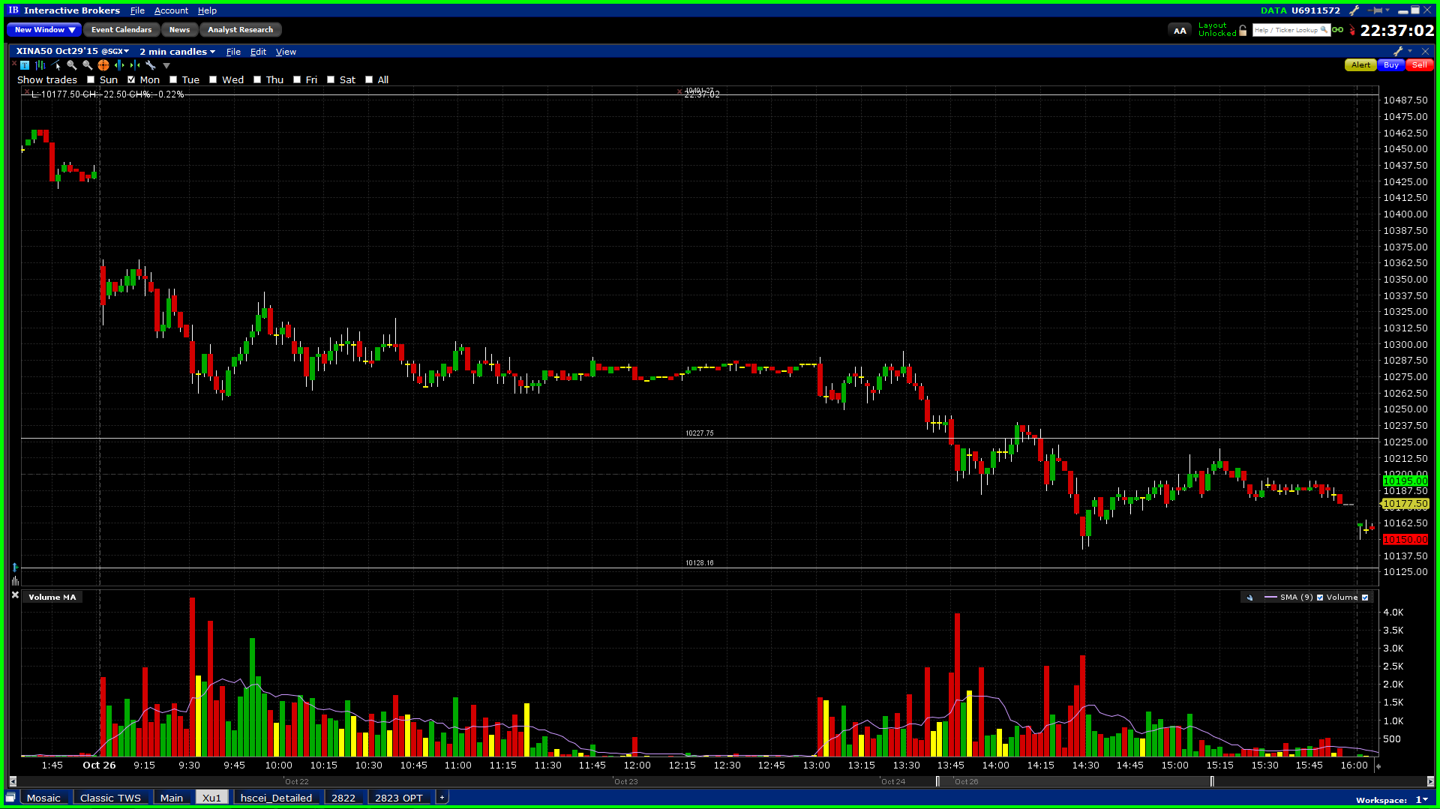

10.27.2015

Typical PTC pattern. Retraced 5% from last Friday evening highs (15000). Rebounded 1.5% in the afternoon.

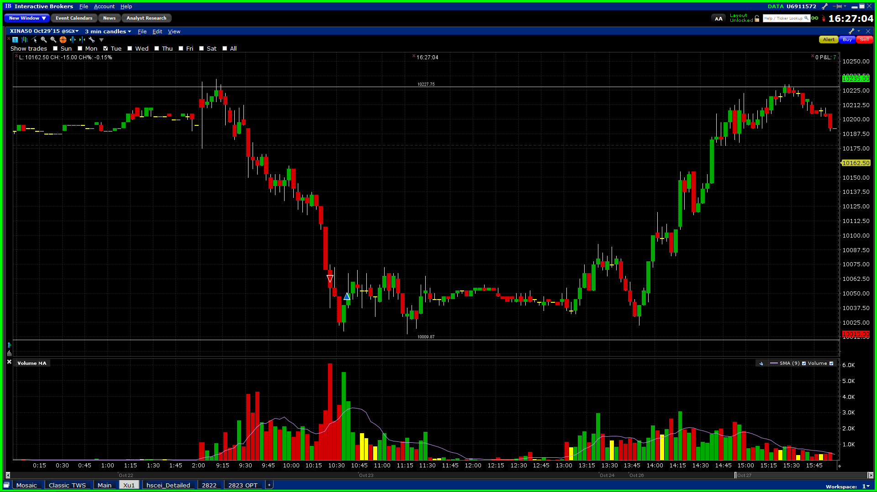

1028

Afternoon pullup failed, sentiment starts to turn bearish. Market fighting with the 60D MA. (The selling point is very bad, at the lowest point of the day. Think ETF-futures equivalence when trading. Focus on relative position and not the movement direction)

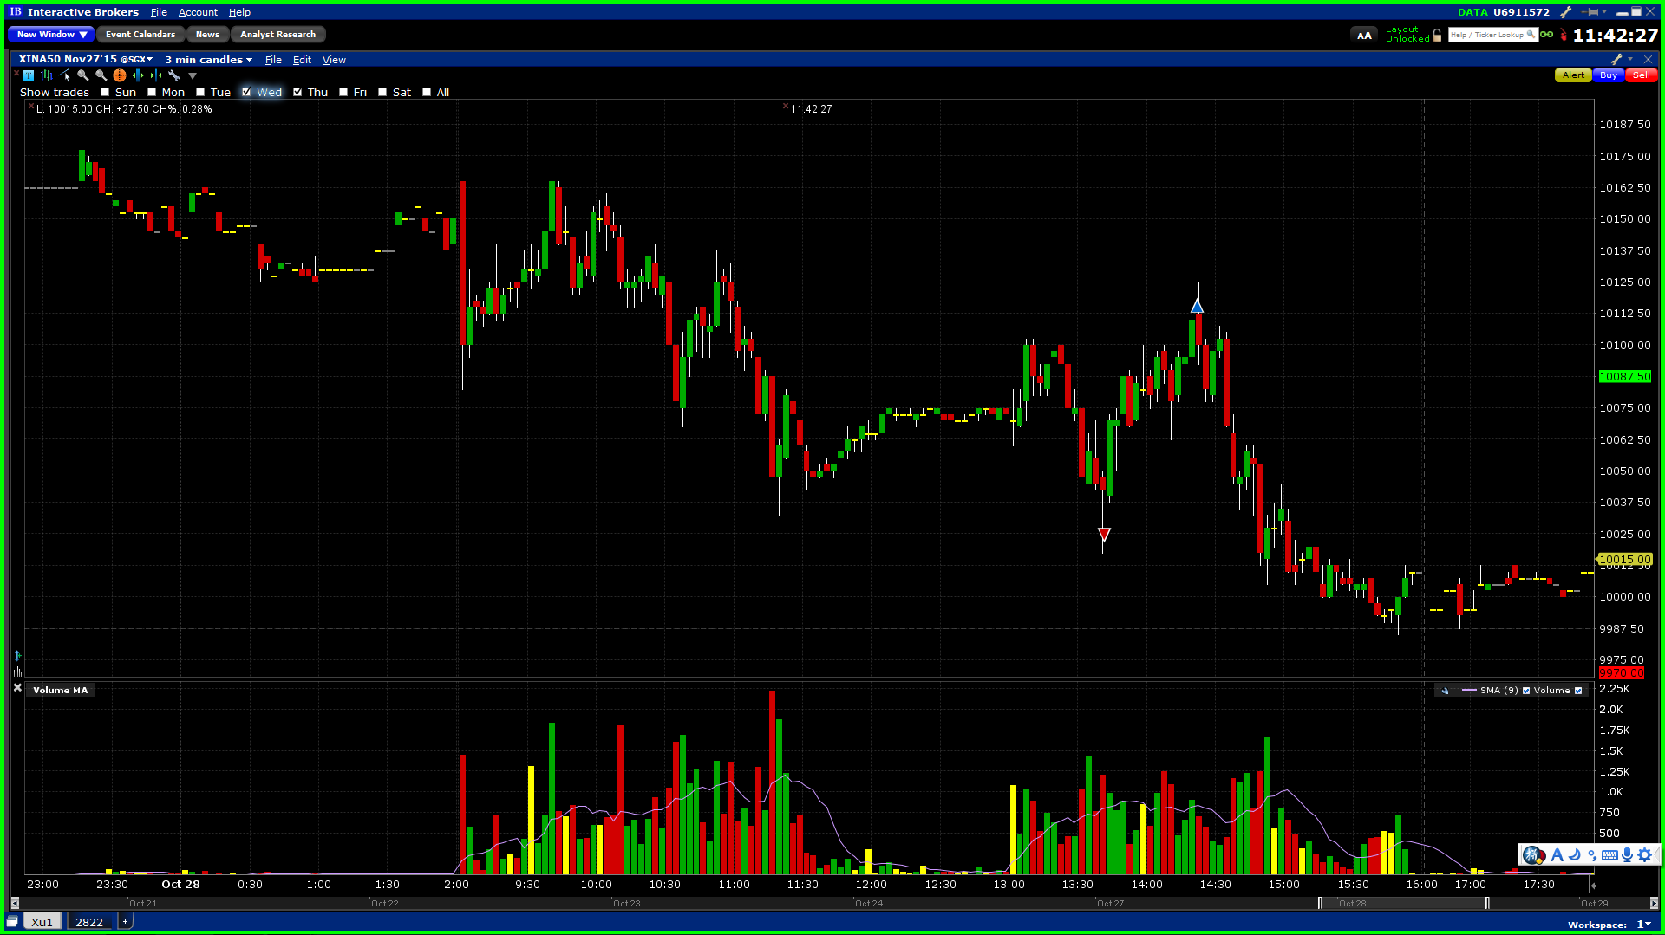

1029

Afternoon pull up failed two days in a row (with yesterday). Weekly candle is negative, possibly signaling the end of this rally. US overnight was with no apparent direction.

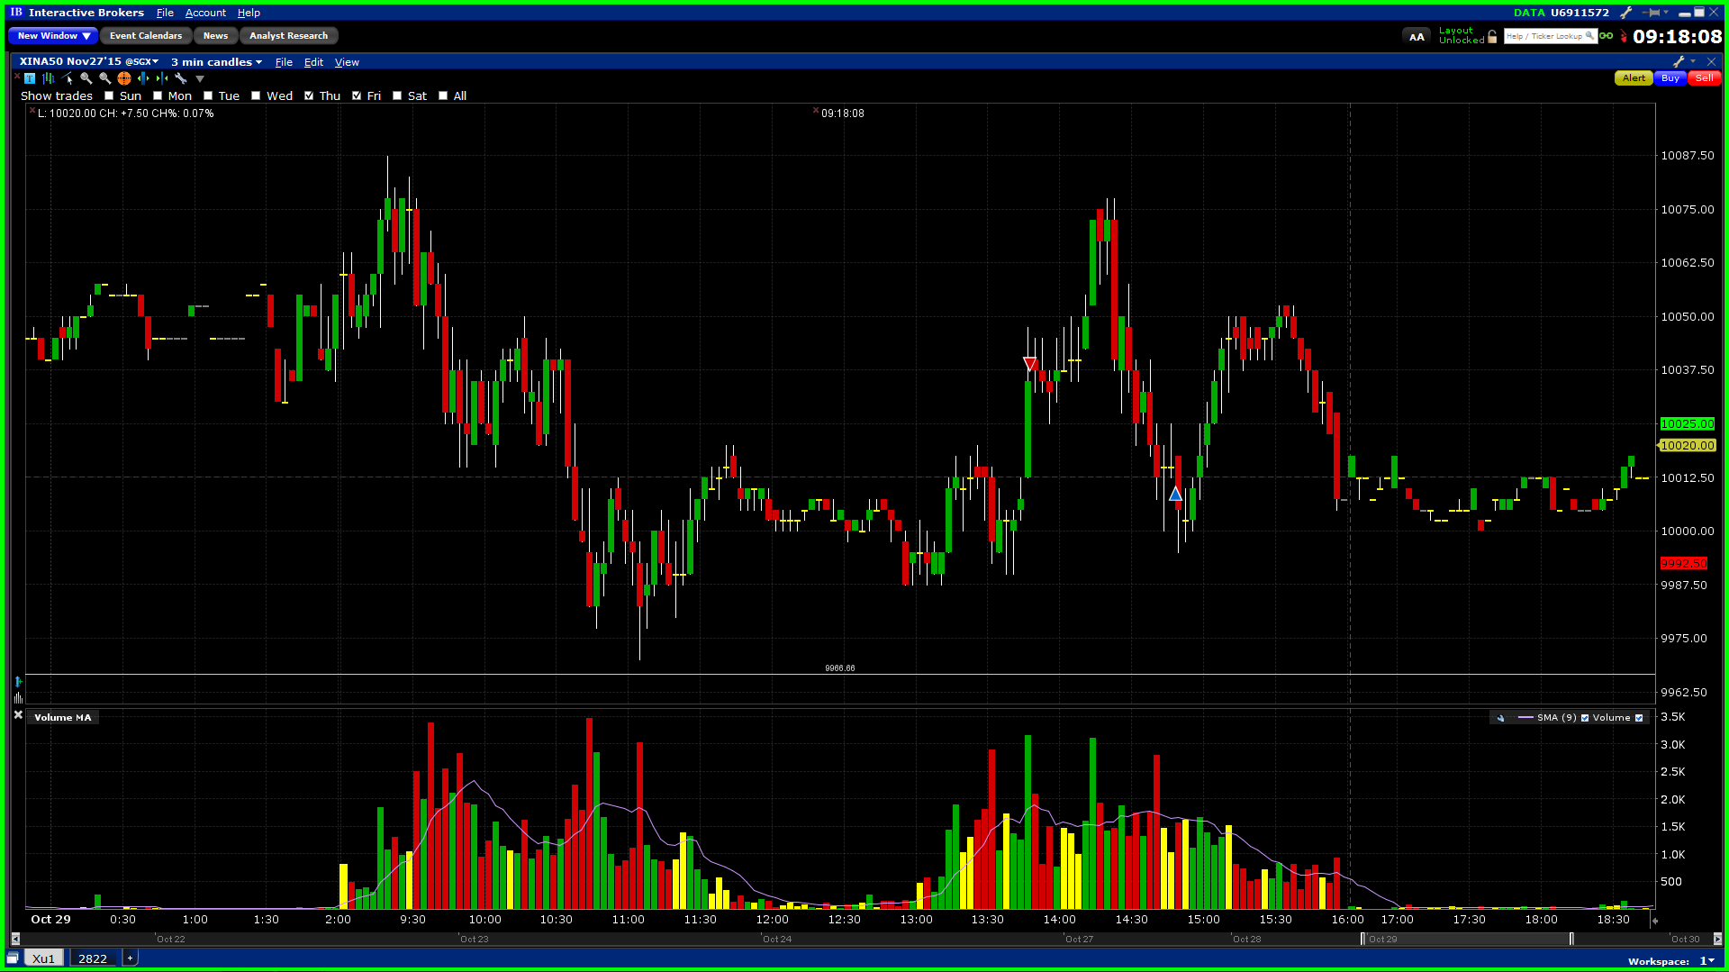

10.30

Weekly 1026-1030

Opened 10360, closed 9980.

Trades: wed: sold at the lows 10020, covered @ 10120. Sold @ the lows. (This broke the rules)

Fri: Cover shorts every 30-50 points gain on average. Proactively cover shorts, not wait until stop loss is hit, sitting there paralyzed.

Improvements needed:

1. Proactively take profits.
2. Sell only on the way top or at the top especially when rallying high. Suppose in short position and want to cover.
3. Sell @ local highs, new highs, all highs.

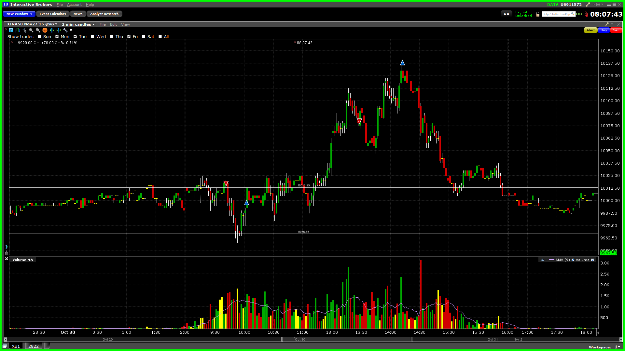

11.2

PMI came out 48.3 (E 47.6, L 47.2)

Entered a bit too early. Read the trend incorrectly. Position was unhedged, could not withstand volatility. Lower net delta to 20k-40k. With 5% move would be 1000 or 2000. (0.5% to 1% of the net portfolio.

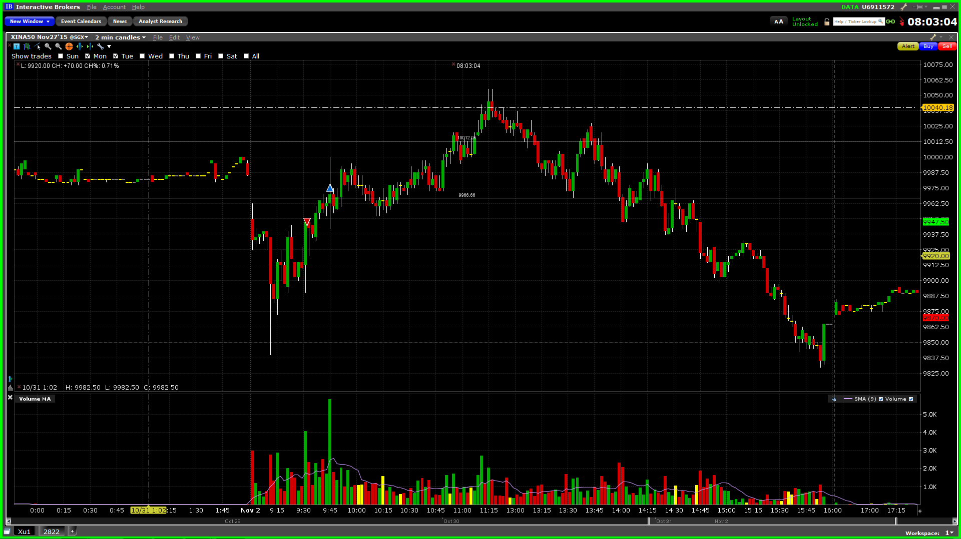

11.3

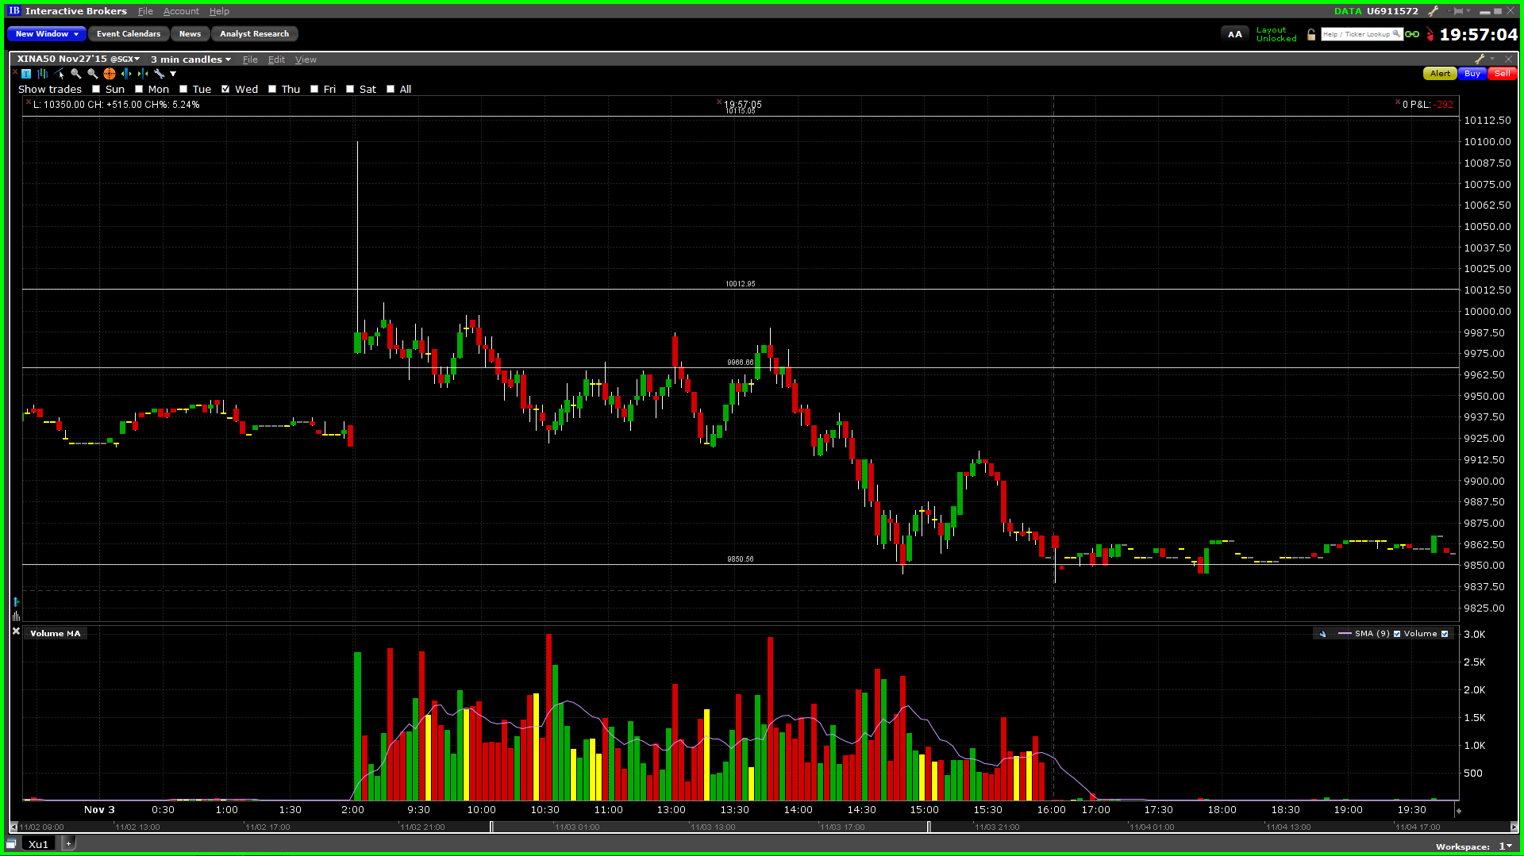

11.4

-300 US. An all-up day. Position size was too large, not flexible enough. Second and third were overtrading.

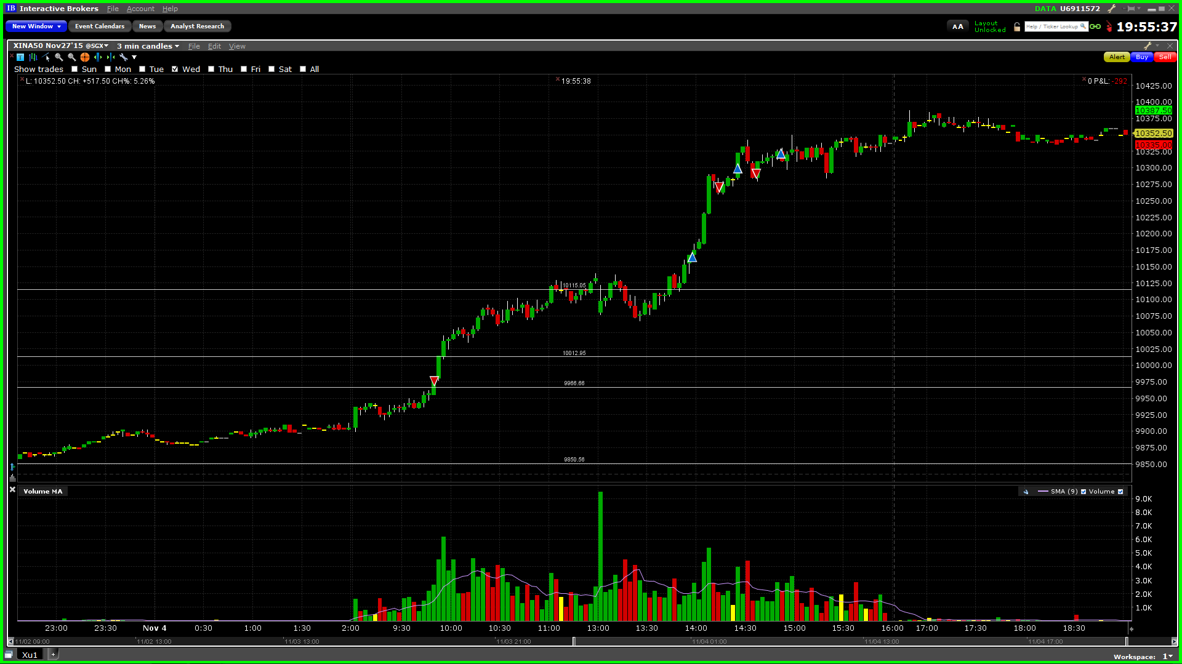

11.5

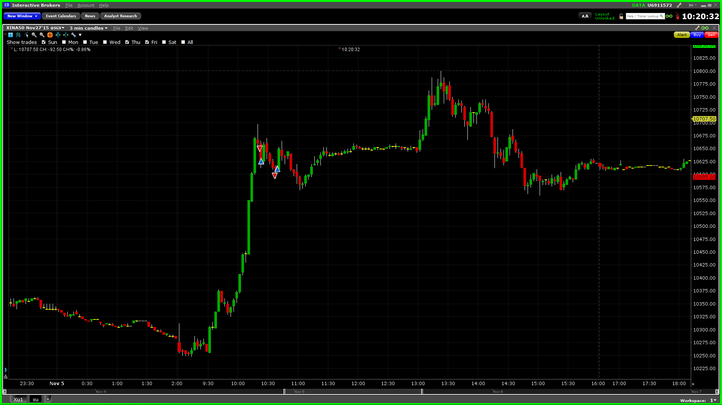

11.6

